10 Things to Do for Erasmus+ Exchange Students in Turkey
Before Departure
- Obtain an acceptance letter for your study or placement from a Turkish University with an Interinstitutional Agreement between your receiving and home (sending) university. Get detailed information on courses/traineeship tasks and issue related documents such as Learning Agreement for Study/Traineeship , Student Grant Agreement etc. with mutual approval of your sending and receiving institution before mobility starts.
- Apply for visa with a valid passport in due time at a Turkish Embassy/Consulate in your country . Entrance without visa is also possible for the citizens of some EU countries but you need to pay some tax and fee for making Residence Permit application in any case.
- Take an online appointment for Student Residence Permit before your arrival (Compulsory for more than 90 days stay) Link: https://e-ikamet.goc.gov.tr/
Note: Student Residence Permit is cheaper than a short term residence permit.
- Health Insurance is mandatory for residence permit. There are three options:
- Health Insurance Policy issued at your home country should be in accordance with the below minimum policy content defined in Turkish Circular no: 9/2014 dated on 6/6/2014. The insurance certificate issued by a foreign company should be translated into Turkish with the approval of notary. However, in the case of host Turkish higher education institutions; if Erasmus Institutional Coordinator validate that the insurance certificate issued by a foreign company is in line with the minimum requirement stated above, the notary translation is not mandatory.
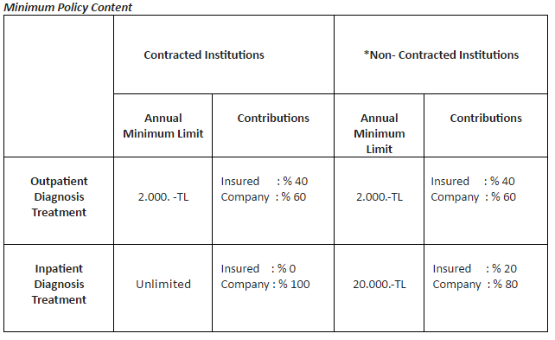

- You can get a Health Insurance Policy with minimum policy content from a private insurance company in Turkey which costs approximetly 15 or 20 € per month after your arrival. In this case Tax number is required as explained in article 6 of this document.

- You can benefit from Turkish Social Security System with approximetly 15 or 20 € per month after your arrival. (More complicated)
Note 1 : Option B is the most common way chosen by Erasmus Students.
Note 2 : Notary Translation in option A is the only way for students coming for placement to a public or private company other than university. Trainees may also select option B or C for Insurance Matter.

After Arrival
(Welcome to Turkey )
- In order to obtain all the necessary information before during and after your Erasmus+ study/traineeship mobility, attend Erasmus+ Orientation Program sessions if available at your host university’s Erasmus+ Office/International Office. Or contact to host university’s Erasmus Office for related documents ( Insurance Policy, Student Declaration Form, Tax number etc. ) required on Residence Permit Application.
- Take a tax number from the closest Tax Office in order to open a bank account or pay for private insurance (article 5.b) if necessary.
- For students conducting an Erasmus+ study/traineeship mobility in an institution in Istanbul, the representatives of the Directorate General for Migration Management (DGMM) will assign an institutional appointment day to your host university. Without being necessary to go to the office for DGMM, you can have your Residence Permit application papers processed at the university. Ask the Erasmus+ Representatives of your host university in Istanbul about details on this appointment type.
- Ask for certificate of receipt during Residence Permit Appointment which allows you to exit from and enter Turkey before Residence Permit issued (especially for holidays such as christmas etc). In case of an extension for your mobility period you can also apply online for extented Residence Permit by https://e-ikamet.goc.gov.tr/ in due time.

- Inform your host Erasmus office about the YU number (Citizenship Number) as soon as you receive with Residence Permit, in order to let them update the temporary one, thus you will be able to benefit from all privileges for students (especially for public transport with discount, discounted entrance to museums , cinema, theatre etc)

- Do not forget to take your Certificate of Attendance and Transcript (if available) from your host university before departure.

Important Notice: this is an informal document including some useful tips prepared for the foreign Erasmus students. Turkish National Agency, cannot be held responsible, in case any contradiction or change may happen with existing rules and regulations. It is the duty of incoming students to learn formal and updated procedures from competent Turkish authorities such as Turkish Ministry of Foreign Affairs and Directorate General For Migration Management

